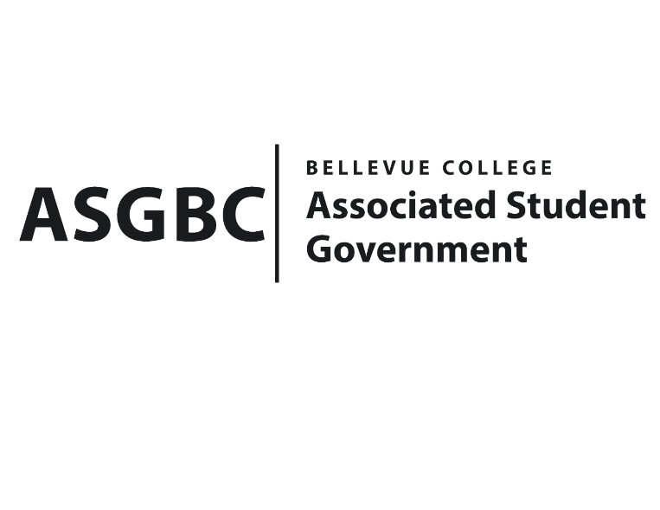
BOARD OF DIRECTORS
Session I
Date: January 12th, 2024
04-01-01

Submitted by Daniel Ngoy, Executive Justice

BOARD BILL 04-01-01: An Act to Adopt the Association’s Legislative Agenda for the 2023-2024 Academic Year.

WHEREAS: The proposed Legislative Agenda provides the Associated Student Government the ability to lobby for specific issues on behalf of the Bellevue College student body in Olympia; and,

WHEREAS: The proposed Legislative Agenda addresses the following items “Support Student Mental Health Services”; “Better Support and Resources for International Students”; “Support Measures to Lower the Cost of Education”; “Implement a Sales Tax Exemption for Required Text and Course Materials”; “Mandatory Prayer/Reflection Rooms”; and “Better Support for Undocumented Students”; and,

WHEREAS: The proposed Legislative Agenda advocates for the betterment of the student experience for all public higher education students in the State of Washington; and,

THEREFORE, BE IT ENACTED BY THE ASSOCIATED STUDENT GOVERNMENT OF BELLEVUE COLLEGE BOARD OF DIRECTORS

THAT: The Associated Student Government of Bellevue College hereby adopts the proposed legislative agenda; and,

THAT: A copy of the legislative agenda be published and uploaded publicly within five business days of its approval; and,

THAT: A copy of this bill be sent to Isadora Silva, Emerging Technology Representative, and all current ASG personnel.

End

I, Sean Behl, President of the Associated Student Government of Bellevue College, do herby certify that Board Bill 04-01-01 was duly approved by the Board of Directors on 01/12/2024. I attest to the accuracy and authenticity of the contents of this bill.


__________________________________
Sean Behl
ASG President

