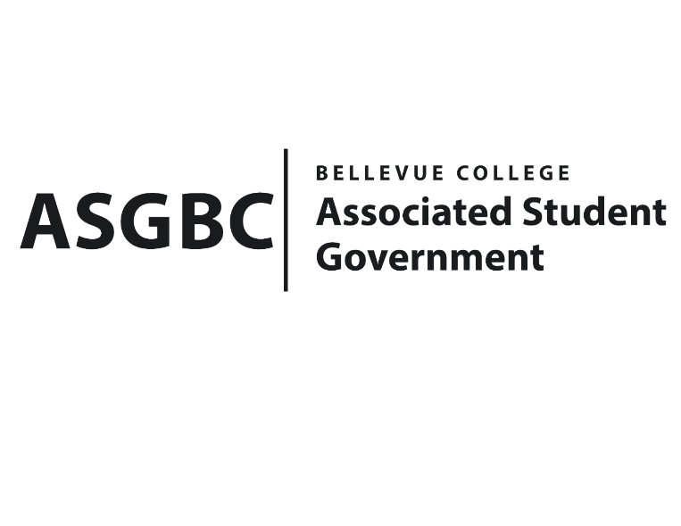
BOARD OF DIRECTORS
Session I
Date: January 26^{h}, 2024
03-01-08

Submitted by Heidi Ngo, Treasurer

BOARD BILL 03-01-08: An Act to Approve the SESF Northwest Model United Nations Conference Funding Request in the Amount of $5500.

WHEREAS: The United Nations Club plans to attend the Northwest Model United Nations Conference, it is an educational simulation of the United Nations; and,

WHEREAS: The United Nations Club plans to participate as a representative of a specific country and tackle real world issues from their country's perspective.

WHEREAS: The SESF Committee has approved the allocation of $5500 for the Northwest Model United Nations Conference.

THEREFORE, BE IT ENACTED BY THE ASSOCIATED STUDENT GOVERNMENT OF BELLEVUE COLLEGE BOARD OF DIRECTORS

THAT: The Associated Student Government of Bellevue College approves the allocation of $5500 to fund the SESF Northwest Model United Nations Conference; and,

THAT: A copy of this bill be forwarded to Heid Ngo, Treasurer; Hristo Stoynov, Office of Student Engagement Program Coordinator; Christina Sciabarra, United Nations Club Advisor; and Daniella Salima, United Nations Club President, and the SESF Committee.

End

I, Sean Behl, President of the Associated Student Government of Bellevue College, do herby certify that Board Bill 03-01-08 was duly approved by the Board of Directors on 01/26/2024. I attest to the accuracy and authenticity of the contents of this bill.
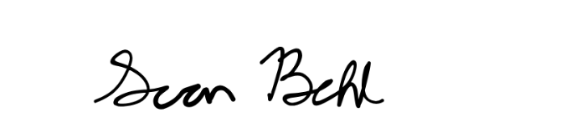

__________________________________
Sean Behl
ASG President

