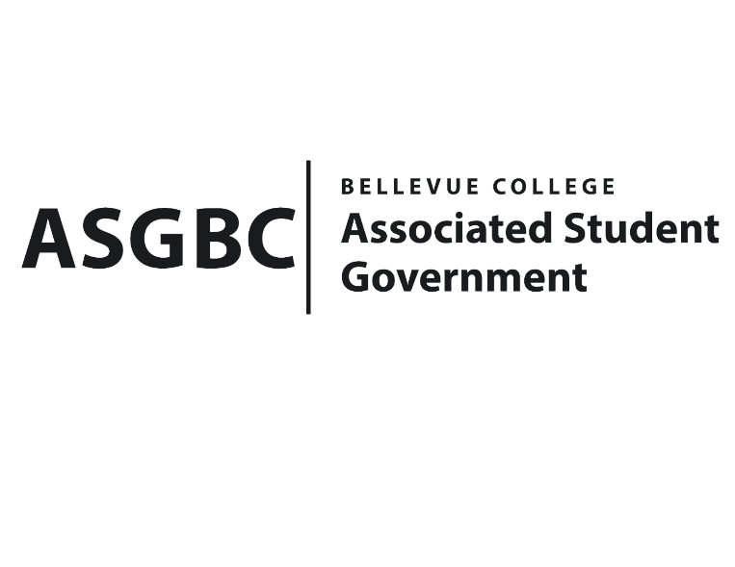
BOARD OF DIRECTORS
Session I
Date: January 26^{h}, 2024
03-01-06

Submitted by Heidi Ngo, Treasurer

BOARD BILL 03-01-06: An Act to Approve the Rocketry and Aerospace Club Rocket Kit Funding and Membership Fee Funding Request in the Amount of $3500.00.

WHEREAS: The Rocket and Aerospace Club seeks to receive funds to purchase Rocket Kits and use the materials to get Students to qualify to get an L1 High power rocketry certification. They will also be using the funds to travel to Pasco, Washington to get a level 1 certification and become licensed high-power rocketeers; and,

WHEREAS: The Rocket and Aerospace Club seeks to hopes gets their members one step closer to becoming fully licensed rocketeers; and,

WHEREAS: The Rocket and Aerospace Club aims to develop interest in aerospace, this opportunity allows members to put their knowledge of rocketry to work.

THEREFORE, BE IT ENACTED BY THE ASSOCIATED STUDENT GOVERNMENT OF BELLEVUE COLLEGE BOARD OF DIRECTORS

THAT: The Associated Student Government of Bellevue College approves the allocation of $3500 to fund the Rocketry and Aerospace Club Rocket Kit Funding and Membership Fee Funding Request; and,

THAT: A copy of this bill be forwarded to Heid Ngo, Treasurer; Hristo Stoynov, Office of Student Engagement Program Coordinator; Trevor Gamble, Rocketry and Aerospace Club Advisor; and Anagha Spreepada Rao, Rocketry and Aerospace Club President.

End

I, Sean Behl, President of the Associated Student Government of Bellevue College, do herby certify that Board Bill 03-01-06 was duly approved by the Board of Directors on 01/26/2024. I attest to the accuracy and authenticity of the contents of this bill.


__________________________________
Sean Behl
ASG President

