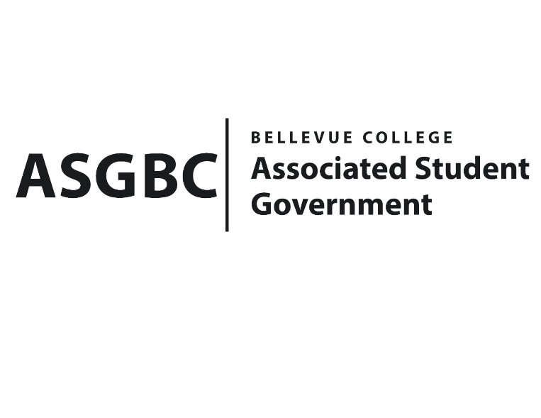
BOARD OF DIRECTORS
Session I
Date: January 26^{h}, 2024
03-01-05

Submitted by Heidi Ngo, Treasurer

BOARD BILL 03-01-05: An Act to Approve United Nations Club First Club Meeting of the Quarter Funding Request in the Amount of $1153.36

WHEREAS: The Model United Nations Club seeks to receive funds to gain continuous attendance, they want to create extra excitement during their first meeting of the quarter; and,

WHEREAS: The Model United Nations Club plans to use snacks to stir conversation and bring back past and potentially new members to attendance at their first meeting; and,

WHEREAS: The Model United Nations Club hopes to connect with new and returning members and educate them about the United Nations, its goals, and what we they do to create change as many of their club members come from diverse and/or international background.

THEREFORE, BE IT ENACTED BY THE ASSOCIATED STUDENT GOVERNMENT OF BELLEVUE COLLEGE BOARD OF DIRECTORS

THAT: The Associated Student Government of Bellevue College approves the allocation of $1153.36 to fund Model United Nations Club First Club Meeting of The Quarter; and,

THAT: A copy of this bill be forwarded to Heid Ngo, Treasurer and Hristo Stoynov, Office of Student Engagement Program Coordinator. Christina Sciabarra, United Nations Club Advisor, and Daniella Salima, United Nations Club President.

End

I, Sean Behl, President of the Associated Student Government of Bellevue College, do herby certify that Board Bill 03-01-05 was duly approved by the Board of Directors on 01/26/2024. I attest to the accuracy and authenticity of the contents of this bill.
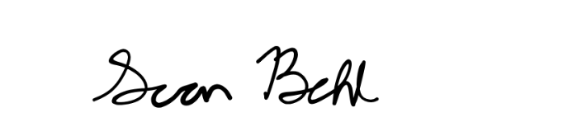

__________________________________
Sean Behl
ASG President

