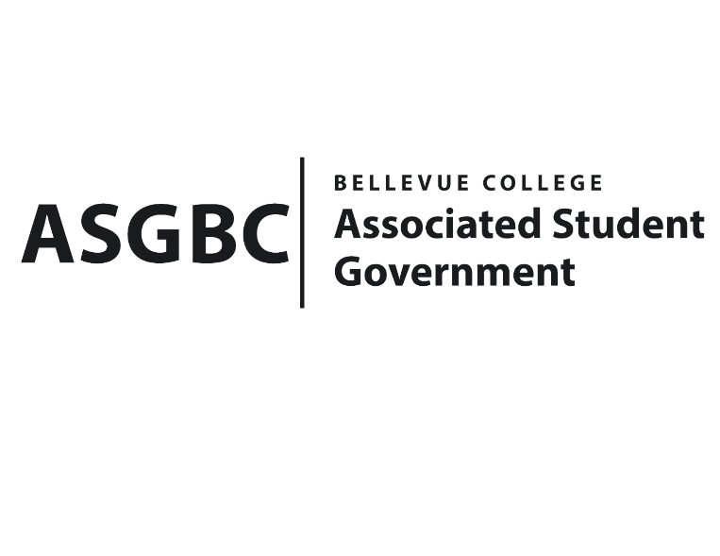
BOARD OF DIRECTORS
Session I
Date: January 19^{h}, 2024
03-01-03

Submitted by Heidi Ngo, Treasurer

BOARD BILL 03-01-03: An Act to Approve the Sewing and Textile Arts Club Valentine’s Day Amigurumi Sale Funding Request in the Amount of $395.

WHEREAS: The Sewing and Textile Ats Club seeks to receive funds to host a series of crochet workshops culminating in an Amigurumi "adoption event" during the week of Valentine’s Day; and,

WHEREAS: The Sewing and Textile Arts Club plans to fundraise an event for their club. They are hoping the money earned through this event will propel their club for the remainder of the school year; and,

WHEREAS: The Sewing and Textile Arts Club believes that this event will advertise, get more people engaged with their club, and strengthen BC's creative community.

THEREFORE, BE IT ENACTED BY THE ASSOCIATED STUDENT GOVERNMENT OF BELLEVUE COLLEGE BOARD OF DIRECTORS

THAT: The Associated Student Government of Bellevue College approves the allocation of $395 to fund the Sewing and Textile Ats Club Valentine’s Day Amigurumi sale for the 2023-2024 academic year; and

THAT: A copy of this bill be forwarded to Heid Ngo, Treasurer and Hristo Stoynov, Office of Student Engagement Program Coordinator, Julie Nguyen, ASG Secretary, Grady Blacken, Sewing and Textile Arts Club Advisor, Makenna Lakin, Sewing and Textile Arts Club President.

End

I, Sean Behl, President of the Associated Student Government of Bellevue College, do herby certify that Board Bill 03-01-03 was duly approved by the Board of Directors on 01/12/2024. I attest to the accuracy and authenticity of the contents of this bill.


__________________________________
Sean Behl
ASG President

